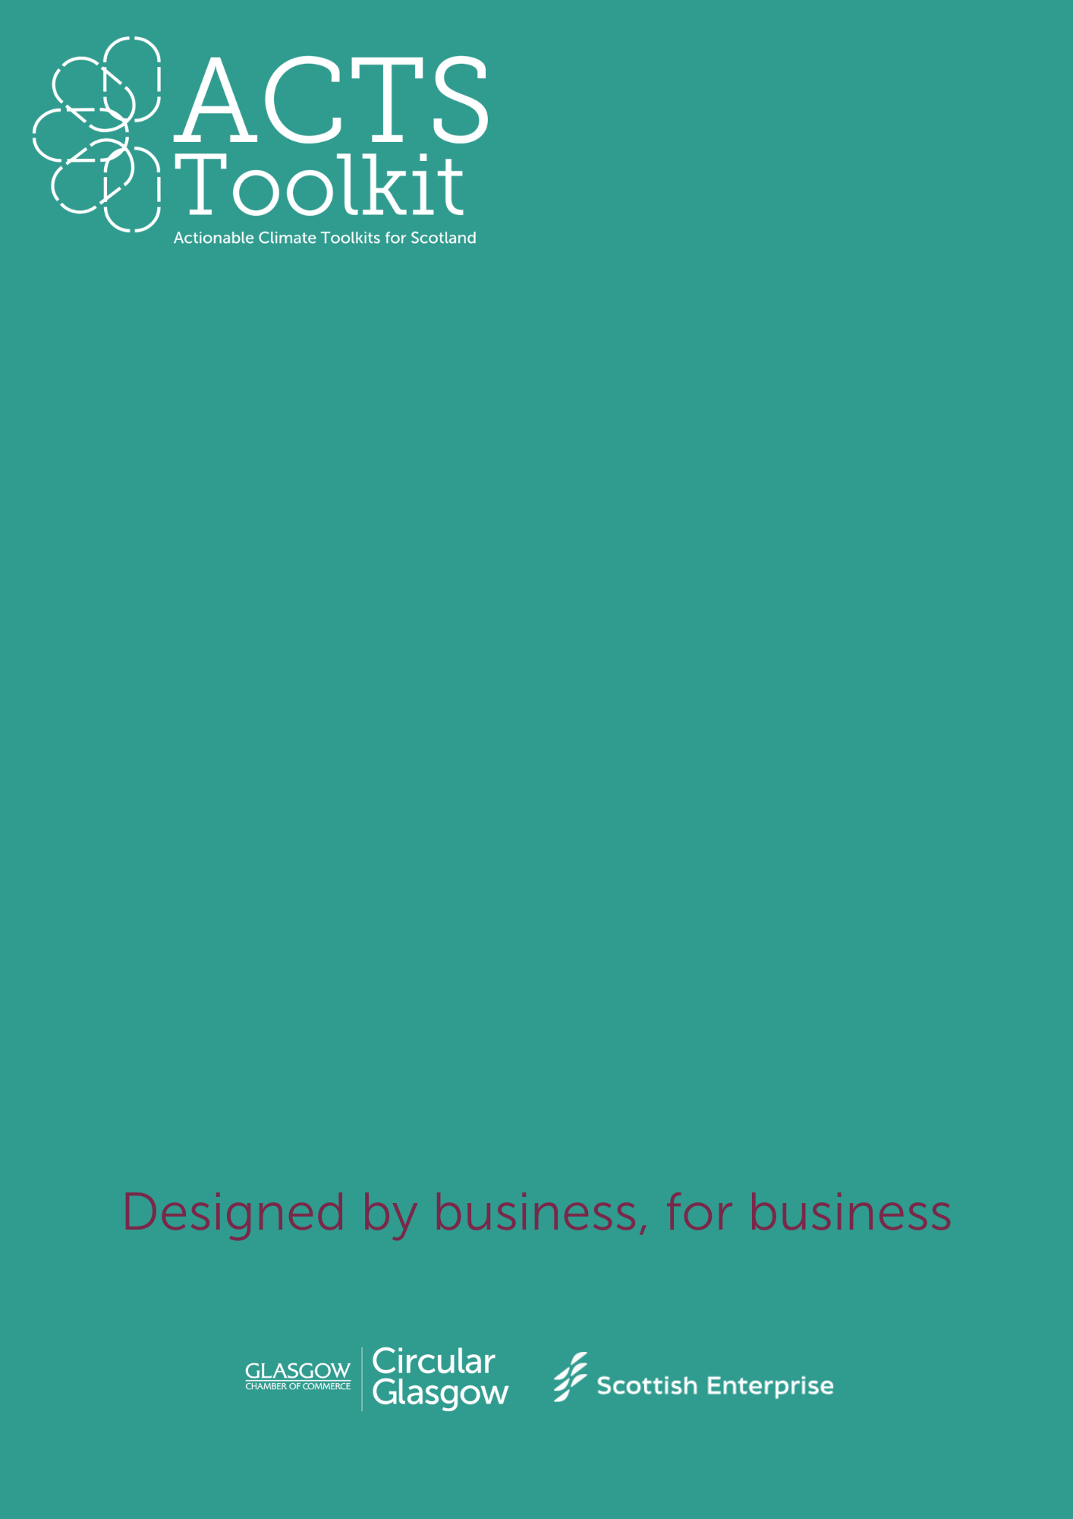

Third Sector and Community Outreach

Guide – Writing a Waste Reduction Plan

**GUIDE – WRITING A WASTE REDUCTION PLAN**

This document is aimed at supporting SMEs to develop their own **Waste Reduction Plan**.

**SECTION 1 – Introduction**

Complete the boxes below:

|  |  |
| --- | --- |
| **Company Name** |  |
| **Date of Plan Creation** |  |
| **Responsible person(s)/team(s)** |  |

**SECTION 2 – Company statement**

Your statement should outline your commitment to reducing your waste and improving resource efficiencies, and how this ties into your wider company values on sustainability.

**SECTION 3 – Waste Audit Results & Categories**

Your waste audit data should be extrapolated to demonstrate a typical volume of waste over a given time period.

**Waste Categories**

For each waste category, indicate your current waste volume and reduction goal.

|  |  |  |
| --- | --- | --- |
| **Waste Type** | **Current Volume** | **Reduction Goal** |
| **General Waste** |  |  |
| **Recyclable Waste** |  |  |
| **Organic Waste** |  |  |
| **Hazardous Waste** |  |  |
| **Electronic Waste** |  |  |
| **Packaging Waste** |  |  |
| **Other Waste** |  |  |

**SECTION 4 – Carbon Reduction Targets**

Outline your SMART targets:

* Specific – what are you going to reduce, and by how much?
* Measurable – how much will you reduce your waste by?
* Actionable – are your goals realistic?
* Relevant – does your reduction goal fit with your company values?
* Timely – how long will it take you to meet your goal?

|  |  |  |
| --- | --- | --- |
| **Timeframe** | **Goal** *examples* | **Progress** |
| **Short-term** | *Over a period of 12 months, we will reduce waste by 20% through better recycling initiatives.* |  |
| **Medium-Term** | *Within 18 months, we will achieve a 50% reduction in packaging waste by working with our suppliers to develop more sustainable packaging alternatives.* |  |
| **Long-term** | *By 2030 we will transition to a zero-waste-to-landfill operation by embracing circular economy principles and advanced waste diversion strategies.* |  |

**Areas to focus on:**

* Waste Segregation and recycling
* Sustainable Procurement methods
* Waste prevention through improved design and management
* Reduction of waste at source
* Employee awareness and engagement campaigns
* Circular Economy integration

**SECTION 5 – Monitoring & Reporting**

Consider how you will track your progress, the frequency of your data collection and who will be responsible for overseeing each area within the business.

Set out your reporting process and frequency – use the table below for guidance:

|  |  |  |  |  |  |  |
| --- | --- | --- | --- | --- | --- | --- |
| **Emission Source** | **Baseline Year Value** | **Current Year Value** | **Reduction Goal** | **% Change** | **Actions taken** | **Next Steps** |
| General Waste (t) | X (t) | Y (t) | 25% by 2030 |  | Implemented office wide waste segregation. | Review waste contractor arrangements. |
| Recyclable materials (t) | X t | Y t | 60% by 2030 |  | Partnered with a recycling service provider. | Expand recycling program to all departments. |

You may also wish to include:

* Who is responsible for what?
* How frequently this will be reviewed?
* How will you refine your goals?