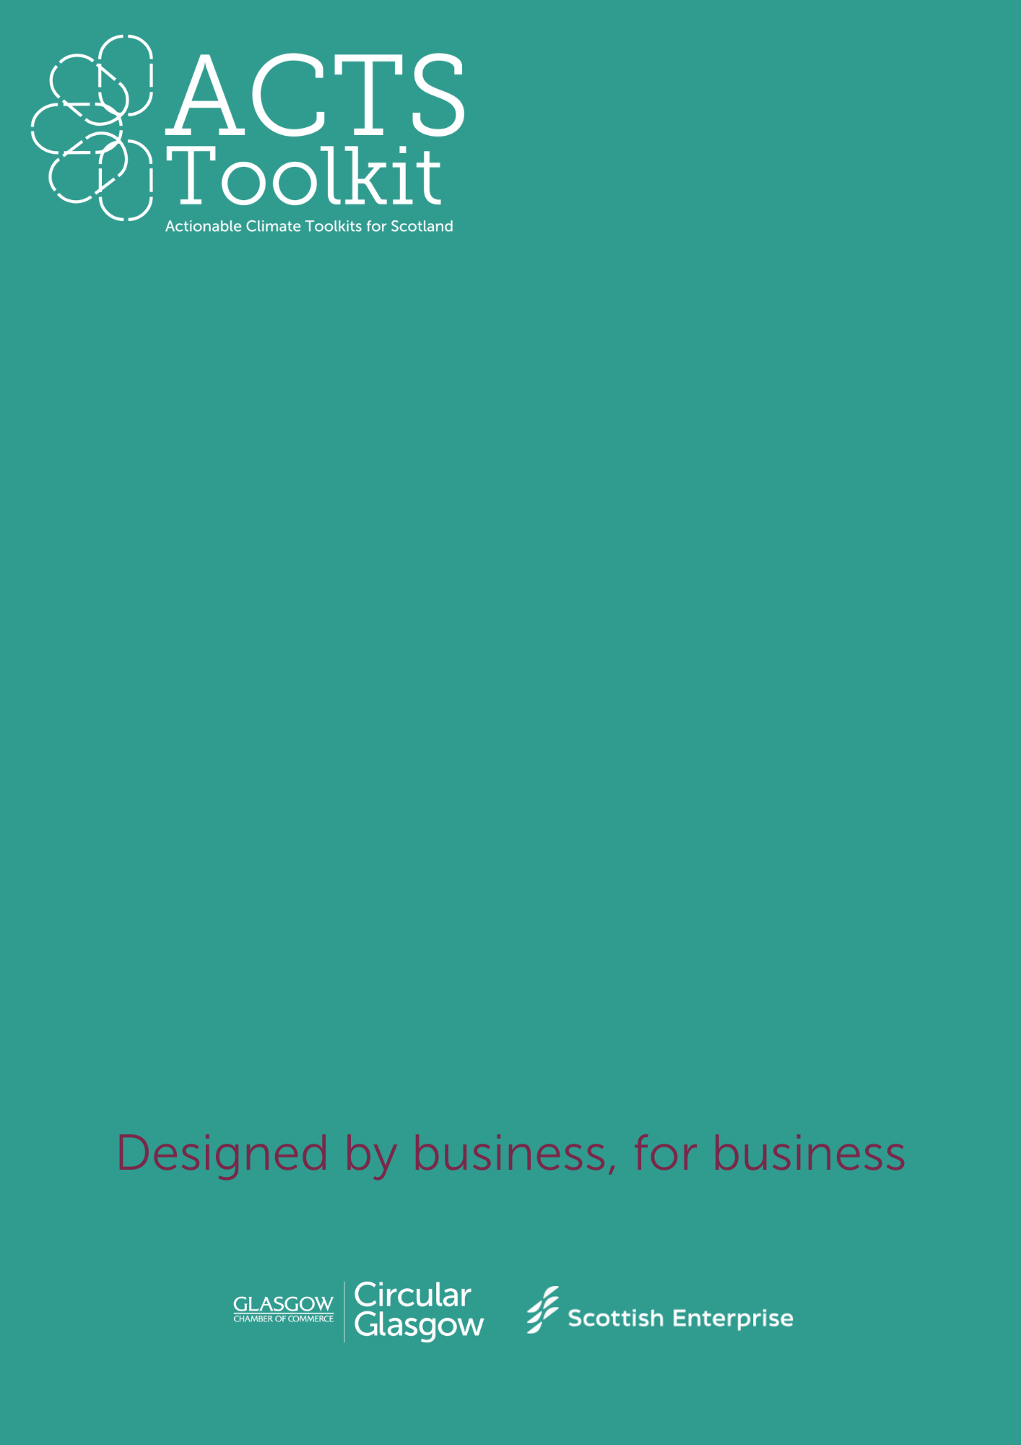
Professional Services and Manufacturing
Writing a Policy
Document
Writing a Policy Document
Your Environmental Policy should be clear, concise, and ideally stick to one page.
Here is a suggested format that you could use:
Introduction & Purpose
- State your commitment to sustainability and achieving net zero.
- Align environmental values with your business goals.
Scope
- Define which parts of your business that will be included in your policy document.
- Clarify what will be included in your Scope 1, 2, and 3 emission calculations.
Environmental Objectives & Targets
- Set SMART goals (e.g., annual carbon reduction, 100% renewable energy by a target date).
- Establish benchmarks for tracking and monitoring your progress.
Action Plan
- Outline your key strategies, e.g. energy efficiency, waste reduction, supplier engagement.
- Assign who will be responsible for each stage for greater accountability.
- Identify any funding opportunities that can support you, e.g. grants for solar panels or EV charging stations.
Employee & Stakeholder Engagement
- Promote staff participation via training, workshops, and Green Teams.
- Develop an engagement plan for communicating with your suppliers and customers.
Monitoring & Reporting
- Define your KPI metrics, e.g., energy use, carbon emissions, waste reduction.
- Schedule the frequency of your reviews and updates.
- Obtain sign-off by your management team.
Continuous Improvement
- Commit to ongoing sustainability enhancements and innovation.
- Review and update policies in response to best practices, new processes and changes to legislation.

