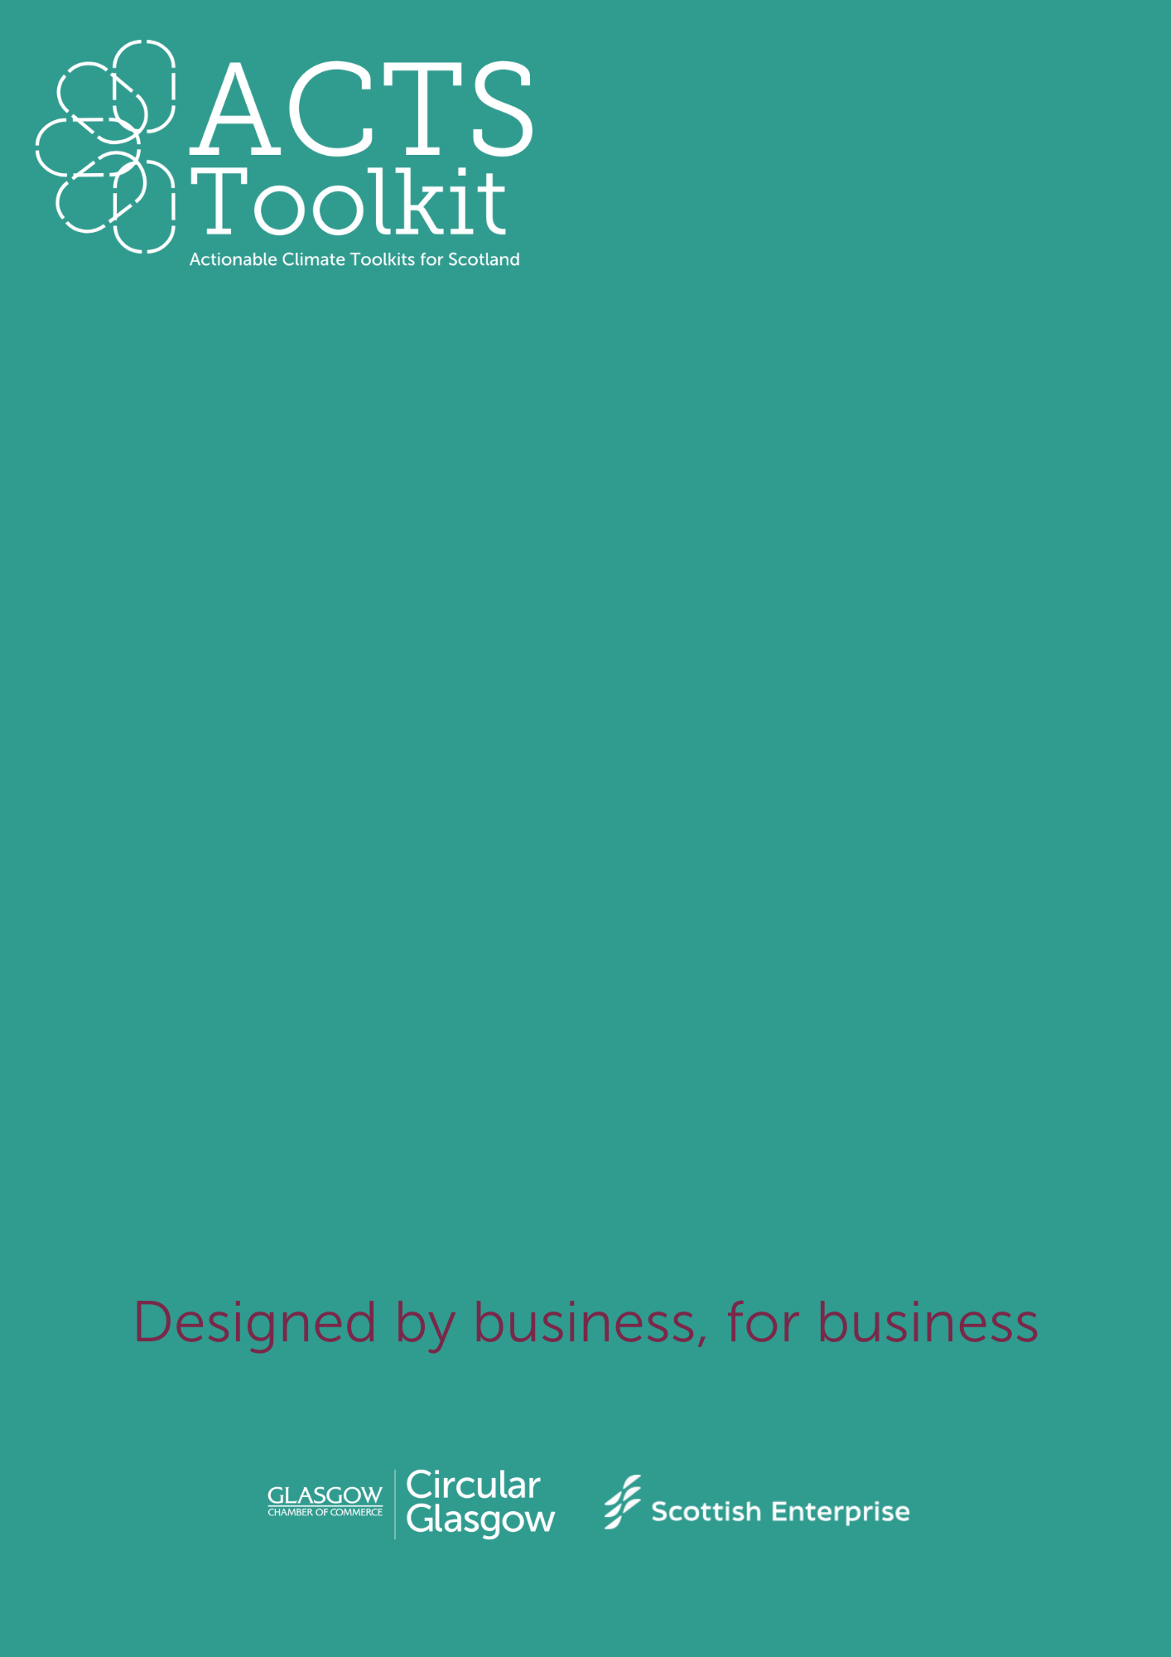
Waste Audit Template
Built Environment and Construction
Waste Audit Template
General Information
Business Name
Location of Audit
Date of Audit
Name of Auditor
Audit Scope (e.g. office, Site 1, etc)

Categories of Waste
Review and assess the volumes for the following waste categories (use weight, volume, or percentage for measurement):
Waste Category | Estimated Volume/Weight | Disposal Method | Comments
Paper and Cardboard
Plastics
Metals (e.g., cans)
Glass
Organic Waste
Hazardous Waste
General Waste

Recycling and Reuse Practices
Evaluate the effectiveness of current recycling and reuse efforts:
- Recyclables Separation: Yes/No
- Reuse Opportunities (e.g., packaging): Yes/No
- Recycling Rate (estimated %):

Waste Disposal Methods
Detail how waste is currently being disposed of:
Disposal Method | Volume/Weight | Comments (e.g., frequency, costs)
Landfill
Recycling Facilities
Composting
Incineration

Cost of Waste Management
- Collection/Disposal Fees:
- Recycling Costs or Revenues:
- Other Associated Costs:

Opportunities for Improvement
List actionable recommendations to reduce waste:
- Waste Reduction Strategies:
- Improved Recycling/Separation:
- Partnering with Recycling Services or Donation Programs:

