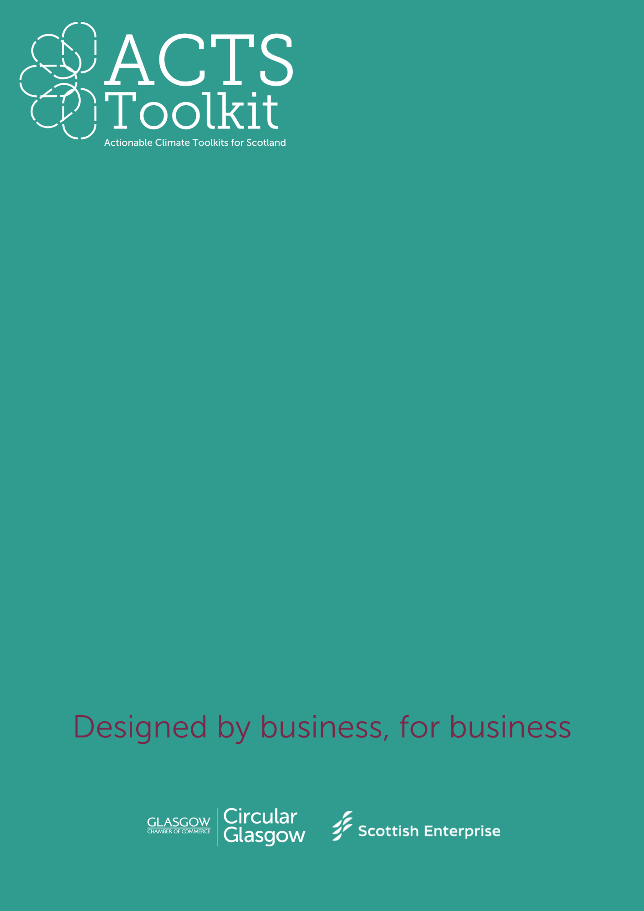
Supplier Questionnaire – Example format
Supplier Questionnaire Example
Built Environment and Construction
Company Name
Services Provided
Contact email / tel
Location
Completed by (name / role)

(COMPANY) are working towards a more sustainable future. We are reviewing our business practices and working towards becoming a net zero organisation, as well as adopting circular economy principles. We kindly ask you to complete the below survey to the best of your ability.
Example Questions
- Do you have an environmental or sustainability policy?
(If yes, please provide a copy or summary)
- YES
- NO
- Does the business have any sustainability related accreditations, e.g. ISO14001, B-Corp?
(If yes, please provide a copy)
- YES
- NO
- Does the business have any emission reduction targets?
(If yes, please specify your targets and progress to date)
- YES
- NO

- Do you measure and/or report your Scope 1, Scope 2 and/or Scope 3 emissions?
(If yes, please provide details)
- YES
- NO
- Do you have any measures in place to improve efficiency and/or reduce waste?
(if yes, please provide examples)
- YES
- NO

- Are your raw materials ethically and sustainably sourced, e.g. certified FSC, Fairtrade.
(if yes, please provide examples)
- YES
- NO

- Are you working towards a net zero target?
(If yes, by when and what steps are you taking to get there?)
- YES
- NO

- Do you offer any schemes such as; material take back, refurbishment, recycling programmes; that are in line with circular economy principles?
(If yes, please provide details)
- YES
- NO

- Do you engage with your own suppliers to improve sustainability within your own supply chain?
- YES
- NO

- Do you have any additional comments?

