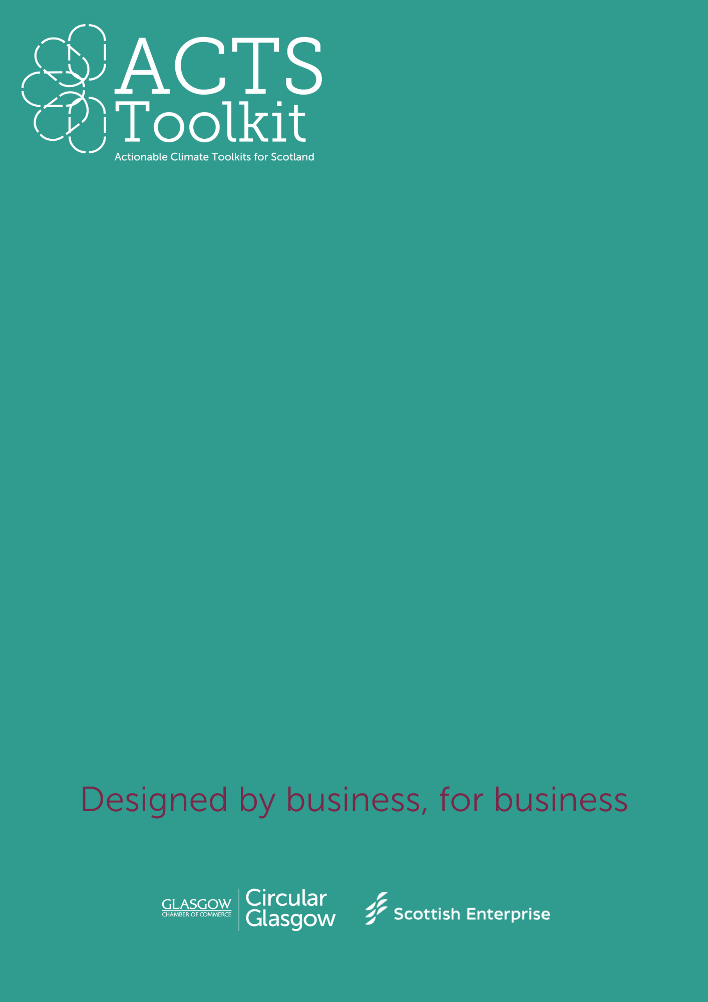**BUILDING YOUR GREEN TEAM**

Where to start

Building your

Green Team

**Introduction**

Appointing a Green Champion or building a Green Team helps to focus your sustainability efforts, promote environmental responsibility, and engage employees in creating a greener, more sustainable business.

Every role has a responsibility for sustainability, working towards net zero and taking advantage of circular opportunities. Having a person or a group of people responsible for driving sustainable change in your business helps to keep everyone accountable.

**Mission**: Choose your mission – it could be reducing your carbon footprint, or working towards a recognised accreditation such as B-Corp status.

**Pick your Team Structure**

* **Green Team Lead**: Responsible for overall direction, coordination, and reporting.
* **Team Members**: Representing different departments or functions, contributing ideas, and leading initiatives.
* **Champion Roles**: Specific team members may be assigned as “Green Champions” within their departments.

**Key Objectives** (examples)

* Reduce energy consumption by X% within X years.
* Cut waste sent to landfill by X% by Xyear.
* Engage employees through X training sessions or workshops annually.
* Collaborate with suppliers to meet sustainability targets.

**Key Strategies & Actions** (examples)

Consider how will you meet your Key Objectives?

**Energy Efficiency**:

* Conduct energy audits.
* Implement energy-saving initiatives (LED lighting, HVAC upgrades, etc.).
* Encourage carpooling, biking, or public transport among employees.

**Waste Reduction**:

* Set up recycling stations in offices and workspaces.
* Introduce a paperless policy or encourage digital document sharing.
* Reduce single-use plastics (e.g., provide reusable cups and bottles).

**Employee Engagement**:

* Hold monthly sustainability meetings to share progress and ideas.
* Develop sustainability workshops or lunch-and-learns.
* Launch an internal sustainability campaign (e.g., "Green Month").

**Timeline & Milestones** (examples)

**Short-term**

* Form Green Team and define initial goals.
* Begin energy audits and waste assessments.
* Host first employee sustainability workshop.

**Medium-term**

* Start implementing energy-saving measures.
* Roll out recycling programs.
* Begin supplier engagement on sustainability.

**Long-term**

* Measure progress against set goals (e.g., energy savings, waste reduction).
* Conduct regular team reviews and update strategy as needed.

**Resources & Support**

* **Budget:** do you need financial support to deliver changes?
* **Training:** are there opportunities for learning and development?
* **External Partnerships:** can you collaborate with others to drive change?

**Reporting & Evaluation**

* **Monthly Check-ins**: Regular team meetings to track progress and discuss challenges.
* **Quarterly Reporting:** Share updates on sustainability metrics (e.g., energy usage, waste reduction, employee engagement) with the entire team/business.
* **Annual Review:** Evaluate progress against goals, celebrate successes, and adjust strategies for the coming year.

**Communication Plan**

* **Internal**: Monthly communications to inform staff about initiatives and progress.
* **External**: Highlight sustainability achievements on your website, in client communications, and through social media.