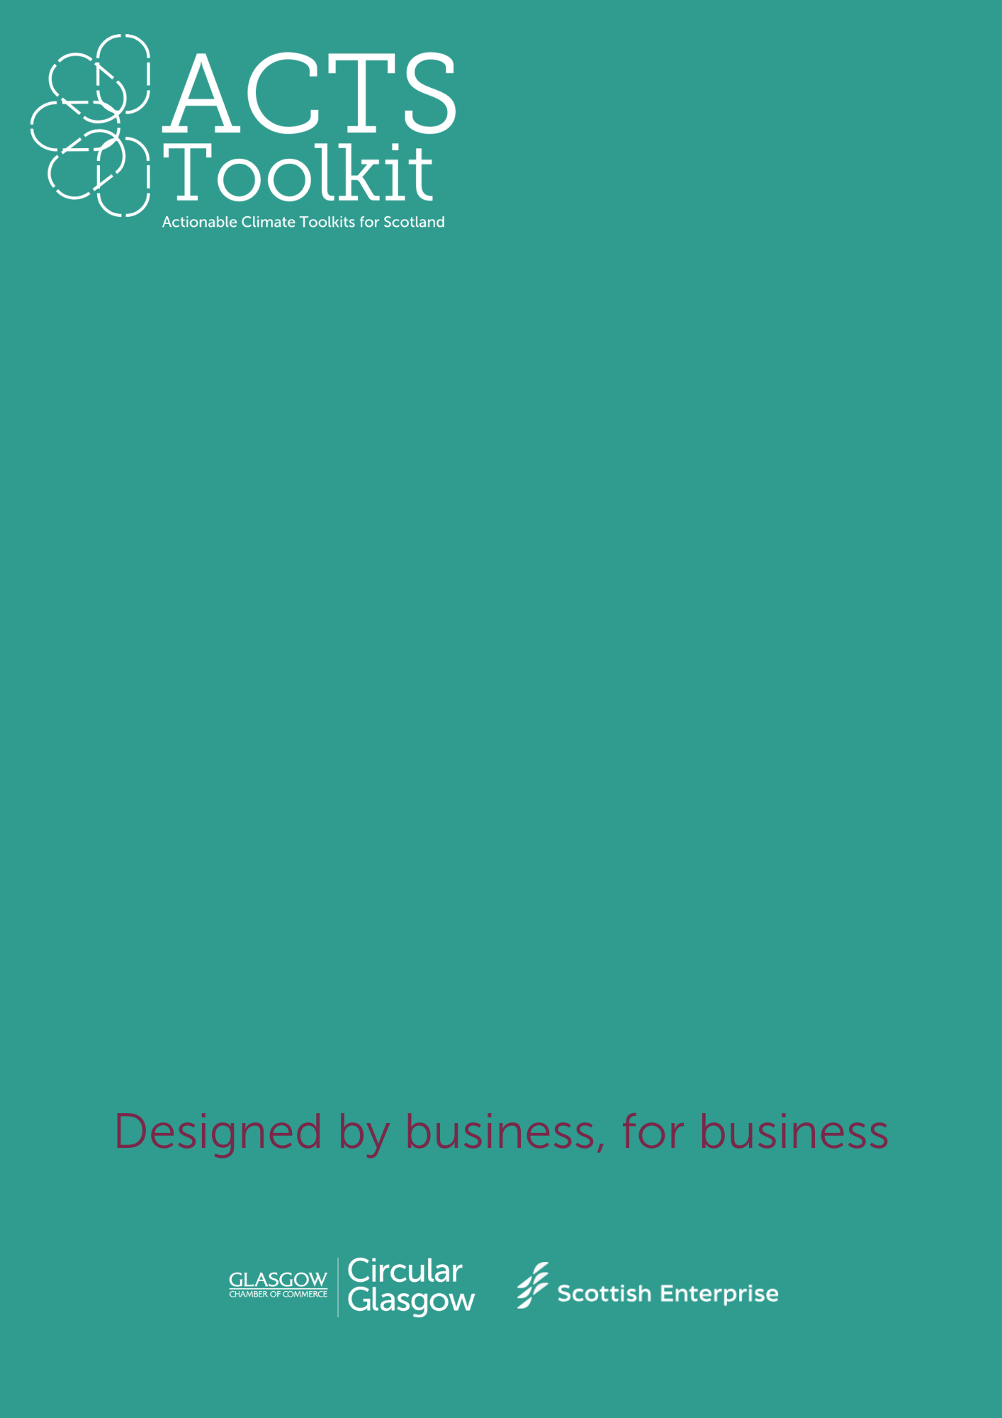

Values and Motivations

For

Sustainability

Arts, Creative and Retail

**Exercise: Understand Your Values and Motivations**

Start by reflecting on why sustainability matters to your business.

Either complete this exercise as an individual, or as part of your first Green Team meeting.

**Defining Your Sustainability Values**

Ask yourself or your team the following questions and note your responses:

* What are our core values as a business?
* Why do we want to become more sustainable (e.g., reducing costs, improving brand reputation, regulatory compliance, or environmental stewardship)?
* What specific environmental impacts does our business have (e.g., energy use, waste, transportation)?
* How do our customers, employees, or stakeholders value sustainability?
* Any other points: